JAVASCRIPT Assignment Question

Question1

Take a sentence as an input and reverse every word in that sentence.

Example - This is a sunny day > shiT si a ynnus yad.  
  
Code:

function reverseWordsInSentence(sentence) {

const words = sentence.split(' ');

const reversedWords = words.map(word => {

return word.split('').reverse().join('');

});

const reversedSentence = reversedWords.join(' ');

return reversedSentence;

}

const inputSentence = "Hyy Morning buddy";

const reversedResult = reverseWordsInSentence(inputSentence);

console.log(reversedResult);

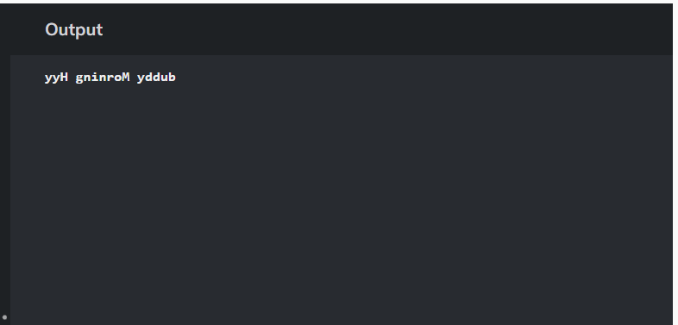output :

Question2

Perform sorting of an array in descending order.

Code:

const originalArray = [10,20,40,50,60];

const descendingArray = originalArray.slice().sort((a, b) => b - a);

console.log(descendingArray);

Output:

